## 

Rodeo Solutions

Develop - Audit - Coach

## 

## 

## ROLiToken Smart Contract Audit

### 

**ROLiToken Smart Contract Audit** **1**

Commision 3

Disclaimer 4

$ROLI Properties 5

Contract Functions 6

Public 6

View 6

Virtual 6

Executables 6

Owner Executables 6

Checklist 7

Potential Issues 8

Main concern 8

Several transfers on deployment 9

Taxes are not clear for potential investors 10

Owner privileges 11

Conclusion 13

### 

### Commision

|  |  |
| --- | --- |
| Audited Project | ROLiToken |
| Project website | <https://rolitoken.com/> |
| Contract Owner | [0x78CAEDF21b765A43b8e419B3E15797d98A148322](https://bscscan.com/address/0x78caedf21b765a43b8e419b3e15797d98a148322) |
| SmartContract Address | [0x53e40cf9a180A5951905F8210300ed16cd0C5cB8](https://bscscan.com/address/0x53e40cf9a180A5951905F8210300ed16cd0C5cB8) |
| Blockchain | Binance Main Smart Chain |

Rodeo Solutions was commissioned by ROLiToken owners to perform an audit of their main smart contract.

The purpose of the audit was to achieve the following:

* Ensure that the smart contract functions as intended.
* Identify potential security issues with the smart contract.

The information in this report should be used to understand the risk exposure of the smart contract, and as a guide to improve the security posture of the smart contract by remediating the issues that were identified.

### 

### Disclaimer

This is a limited report on our findings based on our analysis, in accordance with good industry practice as at the date of this report, in relation to cybersecurity vulnerabilities and issues in the framework and algorithms based on smart contracts, the details of which are set out in this report. In order to get a full view of our analysis, it is crucial for you to read the full report. While we have done our best in conducting our analysis and producing this report, it is important to note that you should not rely on this report and cannot claim against us on the basis of what it says or doesn’t say, or how we produced it, and it is important for you to conduct your own independent investigations before making any decisions. We go into more detail on this in the disclaimer below – please make sure to read it in full.

*DISCLAIMER*: By reading this report or any part of it, you agree to the terms of this disclaimer. If you do not agree to the terms, then please immediately cease reading this report, and delete and destroy any and all copies of this report downloaded and/or printed by you. This report is provided for information purposes only and on a non-reliance basis, and does not constitute investment advice. No one shall have any right to rely on the report or its contents, and Rodeo Solutions and its affiliates (including holding companies, shareholders, subsidiaries, employees, directors, officers and other representatives) (Rodeo Solutions) owe no duty of care towards you or any other person, nor does Rodeo Solutions make any warranty or representation to any person on the accuracy or completeness of the report. The report is provided "as is", without any conditions, warranties or other terms of any kind except as set out in this disclaimer, and Rodeo Solutions hereby excludes all representations, warranties, conditions and other terms (including, without limitation, the warranties implied by law of satisfactory quality, fitness for purpose and the use of reasonable care and skill) which, but for this clause, might have effect in relation to the report. Except and only to the extent that it is prohibited by law, Rodeo Solutions hereby excludes all liability and responsibility, and neither you nor any other person shall have any claim against Rodeo Solutions, for any amount or kind of loss or damage that may result to you or any other person (including without limitation, any direct, indirect, special, punitive, consequential or pure economic loss or damages, or any loss of income, profits, goodwill, data, contracts, use of money, or business interruption, and whether in delict, tort (including without limitation negligence), contract, breach of statutory duty, misrepresentation (whether innocent or negligent) or otherwise under any claim of any nature whatsoever in any jurisdiction) in any way arising from or connected with this report and the use, inability to use or the results of use of this report, and any reliance on this report. The analysis of the security is purely based on the smart contracts alone. No applications or operations were reviewed for security. No product code has been reviewed.

### $ROLI Properties

|  |  |
| --- | --- |
| Contract name | RoliToken |
| Contract address | 0x53e40cf9a180A5951905F8210300ed16cd0C5cB8 |
| Total supply | 1000T |
| Token ticker | ROLI |
| Decimals | 9 |
| Token holders | 1 |
| Transactions count | 1 |
| Top 100 holders dominance | 100.00% |
| Liquidity fee | 4% |
| Tax fee | 4% |
| Total fees | 8% |
| Mintable | No |
| Burnable | No |
| Uniswap V2 pair | 0xd855184236f505cef4d9d0d5cd25d9d471df32eb |
| Contract deployer address | 0x78CAEDF21b765A43b8e419B3E15797d98A148322 |
| Contract’s current owner address | 0x78CAEDF21b765A43b8e419B3E15797d98A148322 |

As of 16/06/2021

### 

### Contract Functions

#### Public

##### View

name()

symbol()

decimals()

totalSupply()

transfer(address recipient, uint256 amount)

allowance(address owner, address spender)

approve(address spender, uint256 amount)

isExcludedFromReward(address account)

totalFees()

reflectionFromToken(uint256 tAmount, bool deductTransferFee)

tokenFromReflection(uint256 rAmount)

##### Virtual

increaseAllowance(address spender, uint256 addedValue)

decreaseAllowance(address spender, uint256 subtractedValue)

##### Executables

balanceOf(address account)

transferFrom(address sender, address recipient, uint256 amount)

#### Owner Executables

excludeFromReward(address account)

excludeFromFee(address account)

includeInFee(address account)

setTaxFeePercent(uint256 taxFee)

setLiquidityFeePercent(uint256 liquidityFee)

setMaxTxPercent(uint256 maxTxPercent)

setSwapAndLiquifyEnabled(bool _enabled)

setTaxEnable(bool _enable)

Extra standard from Ownable Contract

### 

### Checklist

|  |  |
| --- | --- |
| Compiler errors. | Passed |
| Possible delays in data delivery. | Passed |
| Timestamp dependence. | Passed |
| Integer Overflow and Underflow. | Passed |
| DoS with Revert. | Passed |
| DoS with block gas limit. | Low issues |
| Methods execution permissions. | Passed |
| Economy model of the contract. | Passed |
| Private user data leaks. | Passed |
| Malicious Event log. | Passed |
| Scoping and Declarations. | Passed |
| Uninitialized storage pointers. | Passed |
| Arithmetic accuracy. | Passed |
| Design Logic. | Not Passed |
| Cross-function race conditions. | Passed |
| Fallback function security. | Passed |
| Safe Open Zeppelin contracts implementation and usage. | Not Passed |

### 

### Potential Issues

#### Main concern

* 50% of the supply should’ve been burned on deployment.

As stated above the token is not burnable by definition meaning the standard ERC20/IERC20 *_burn* function is not present in the code. In order to have “Manual Burns” as the website states the following code should be incorporated.

<https://github.com/OpenZeppelin/openzeppelin-contracts/blob/master/contracts/token/ERC20/extensions/ERC20Burnable.sol>

In this case what the dev did was that, at the moment of creation when all the properties are defined, he divided the initial supply by 2 and added the result to the Owner address instead of the total supply (1000T) and then burning.



This method wasn’t implemented correctly either as the burned amount wasn’t deducted from the total supply. A couple of additional variables should be added too to show the burned amount and the initial supply.

There are a couple of issues with this method:

* First of all this is not a standard practise so any investor who looks closer at the code will see something not usual happening. This piece of code is not commented on the code either so the objective is not clear just by reading those lines.
* The burnage is not reflected on the totalSupply of the token nor a transaction registered on the blockchain.
* There are no “initial supply“ and “burned” variables.
* No additional burns can be done

#### 

#### Several transfers on deployment

As soon as the contract is deployed several token transfers happen, adding $ROLI to several addresses.

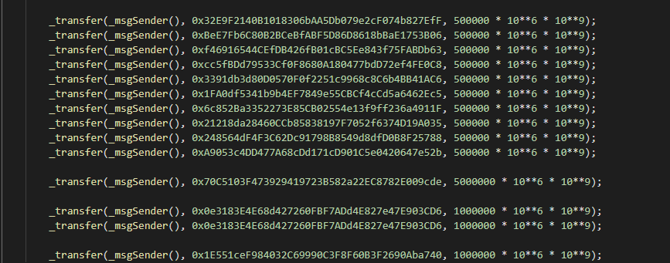

If this was requested as an initial transfer for investors the addresses and amounts should be verified. Otherwise this should be deleted from the code.

This section can be related to “make up dev/admin tokens 13T total dispersed prior to DXsale”, nonetheless, this is not clear in the code and could raise suspicions.

Transfer addresses:

0x32E9F2140B1018306bAA5Db079e2cF074b827EfF

0xBeE7Fb6C80B2BCeBfABF5D86D8618bBaE1753B06

0xf46916544CEfDB426fB01cBC5Ee843f75FABDb63

0xcc5fBDd79533Cf0F8680A180477bdD72ef4FE0C8

0x3391db3d80D0570F0f2251c9968c8C6b4BB41AC6

0x1FA0df5341b9b4EF7849e55CBCf4cCd5a6462Ec5

0x6c852Ba3352273E85CB02554e13f9ff236a4911F

0x21218da28460CCb85838197F7052f6374D19A035

0x248564dF4F3C62Dc91798B8549d8dfD0B8F25788

0xA9053c4DD477A68cDd171cD901C5e0420647e52b

0x70C5103F473929419723B582a22EC8782E009cde

0x0e3183E4E68d427260FBF7ADd4E827e47E903CD6

0x0e3183E4E68d427260FBF7ADd4E827e47E903CD6

0x1E551ceF984032C69990C3F8F60B3F2690Aba740

#### Taxes are not clear for potential investors

When verifying the taxes it’s clear that there are 8% taken from every transaction:

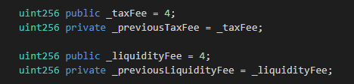

The 8% is also clear on BSCScan:





The issue rises when checking if the taxes are enabled. This is set to false, meaning that currently there are no taxes being taken:





The logic in the transfer function used to send or receive tokens is not clear at first sight which is not very well received by potential investors.

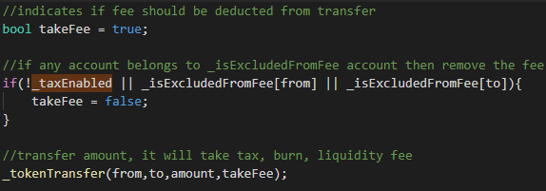

Here it sets a temporal “takeFee” variable as true but if it finds that _taxEnabled is false, it will set that temporal variable to false. Making it indeed not take any taxes from the transactions.

Nonetheless there’s a function to enable the taxes so changing the code is not a must.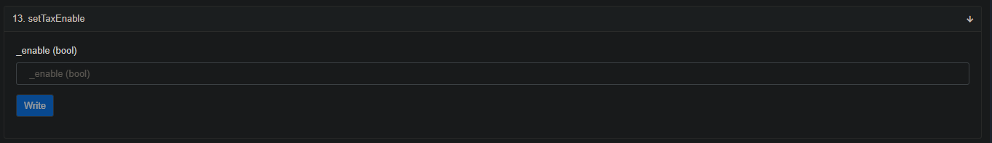

### Owner privileges

* The owner can Exclude or Add an address from the rewards program. Not available on Roli.

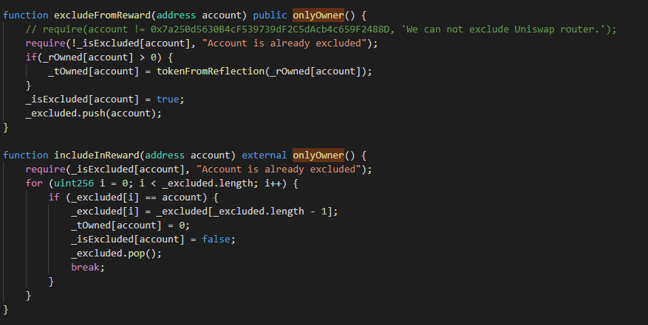

* The owner can Exclude or Add an address from being taxed.

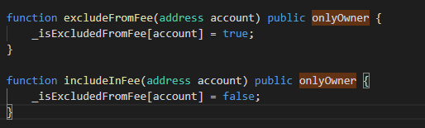

* The owner can change the Tax percentages at any time.

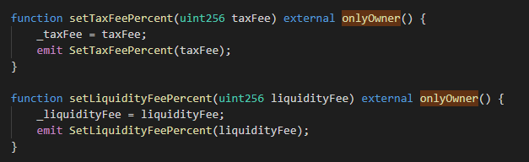

* The owner can enable or disable taxes at any time.

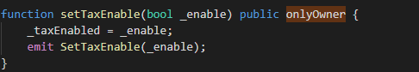

* The owner can toggle the automatic liquidity swap at any time.

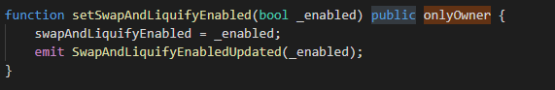

* The owner can set the maximum amount of a transaction at any time.

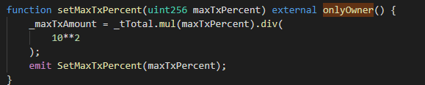

* Additionally the owner can execute the standard functions related to the Ownable Library

### 

### Conclusion

As far as the rest of the code goes, it uses the industry standards taking most of the OpenZeppelin and SafeMath standards. There are not any further concerns and can be verified against the code provided officially in <https://github.com/OpenZeppelin/openzeppelin-contracts>

The code was deployed on the Binance TestNet in order to verify transfer funds from excluded and from not excluded from fees and there are no issues.

Neither in the regular Read functions or Write functions.

The code should have some changes done to it being the following in order of importance:

1. Incorporate the following code <https://github.com/OpenZeppelin/openzeppelin-contracts/blob/master/contracts/token/ERC20/extensions/ERC20Burnable.sol>
2. Burn 50% of the initial supply at the beginning and adding that to the owner address
3. initialSupply variable
4. burnedAmount variable
5. Verify multiple transfers to addresses
6. Change the _taxEnabled variable to True if the contract gets redeployed. Otherwise use the corresponding function to set it to True.
7. Further comments explaining the non-standard logic